C:\Documents and Settings\Teetles\Local Settings\Temporary Internet Files\Content.IE5\YLA072DU\MC900001022[1].wmf

|  |  |
| --- | --- |
| Instructor | Mr. Bayne |
| e-mail | baynerw@staffordschools.net |
| Phone | (540) 658-6080 |

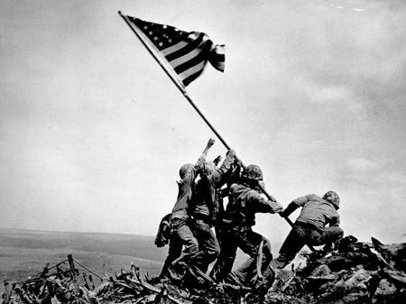Course Description:   
By studying United States and Virginia history students will gain an understanding of the historical development of American ideas and institutions from the age of exploration to the present. With the use of historical and geographic analysis skills, students will explore the major issues, events, ideas, and people in United States and Virginia history giving them a basic knowledge of American culture.

## Grades:

* Daily Assignments—25% Quizzes—10%
* Projects and Presentations—25% Test—Notebooks—40%

Assignments: Assignments are due on their due date at the beginning of class! If the assignment is late, the student will lose points equivalent to one letter grade for each day that it is late. Late work will not be accepted past the final day of the unit test for which the assignment was given.

Brooke Point High School Late-Work Policy

Each day represents a class period

Example: Student did not turn work in on Monday when it was due. Since this class is an XY class, if he turns the work in on Wednesday, he will receive a maximum of 85%. If this were a 4x4 class, the work would be due on Tuesday for a maximum of 85%

* 1 day late: 85%
* 2 day’s late 70%
* 3 day’s late 50%
* 4 days late: 30%
* More than 4 days late = 0

**What is Late??-** Something is considered late if it is not complete and turned in as a hard copy at the beginning of class on the day that it is due. This means that if it is complete and on your flash drive/fusion and needs to be printed and not in hard copy form it is late.



Tutoring: Tutoring is available before school upon request. Any students needing extra assistance are encouraged to take advantage of this opportunity. However, I will not tutor a student who goofs off in class, if you make an effort in class, I will make an effort to help you out.

Supplies:

* Three ringed binder-1 inch
* Loose leaf paper
* Dividers (2)
* Pencils/pens

Class Expectations:

 **Classroom Rules/Expectations-** Along with the student code of conduct students will conduct themselves in a way that contributes to a positive learning environment.

1. Students will Respect themselves, each other, and the learning process.
2. You must be in your assigned seat completing the warm up when the bell rings!!,
3. You must be seated in your seat when the bell rings to be dismissed from class
4. 15 minute rule applies. (You will not be leaving the room fifteen minutes after the bell rings or fifteen minutes before class ends). Students that leave the room for an excessive amount of time will be counted as skipping class
5. Ask about make up work at the END of class. Do not interrupt a lesson to inquire about missing work.
6. No food or drink in the classroom (except bottled water)

Please read through this syllabus carefully. If you have any questions or concerns, feel free to ask either in person, by phone, or via e-mail. I look forward to working with your student in the upcoming semester. If there is anything else that would help me put your student in a better position to succeed please feel free to let me know.

Please Print

Student Name: ______________________ Student Signature:__________________________

Parent Name:_______________________________ Parent Signature: ____________________________  
  
Home Phone Number:____________________Parent E-mail Address:_______________________________

Contact Cell Phone Number: _________________________________________________________________

Preferred method of contact: ( Please circle one)

Phone Email

Please list any information that you thing would help me put your student in the best position to succeed in class.

Sincerely,

Mr. Bayne