Name: _______________ Types of Government Crossword
Across
2. The group that selects Great Britain’s Prime Minister
3. Head (Executive) of Government in Great Britain; chosen by Parliament
4. ___________Monarchy: A King or Queen is the official head of state but power is limited by a constitution.
6. A state of society without government or law.
8. 'Rule by one'
10. A government by the rule of the people
11. A formal organization that directs the political life of a society.
12. Rule by a small, elite group
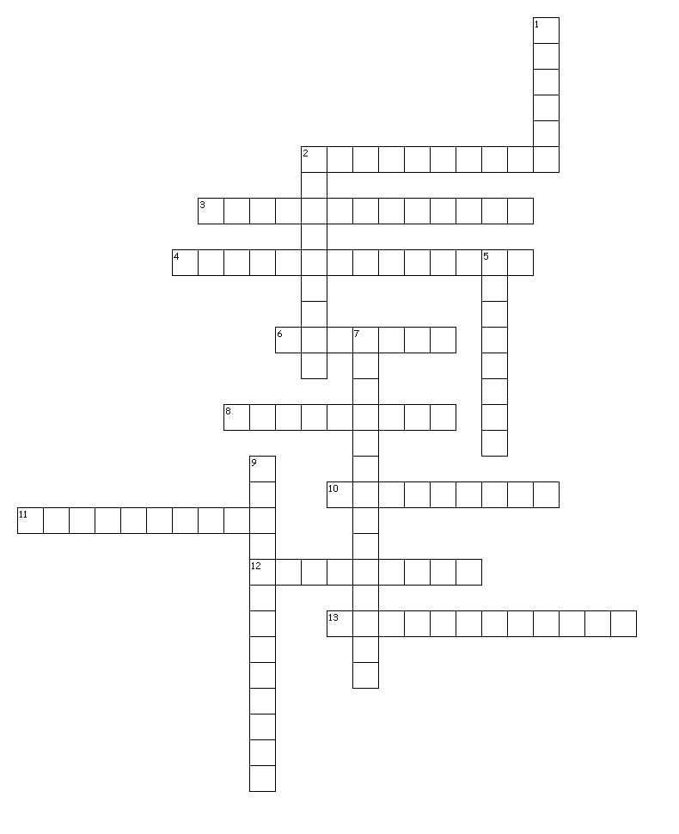
13. A type of government in which the leader has total control over the lives of individual citizens.
Down
1. _________ Democracy: A system of government in which political decisions are made by the people directly
2. Voters in the U.S. system elect this executive.
5. __________Monarchy:A type of government in which the head of state is a hereditary position and the king or queen has almost complete power.
7. __________ Democracy:A system of government in which citizens elect leaders to make decisions about the laws for all the people.
9. A government in which one leader or a small group of people holds absolute power.

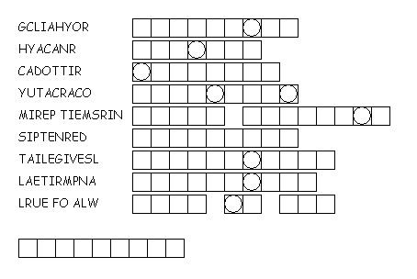
Word Scramble
Unscramble the words below. Then, use the letters that are circled to unscramble the final clue!!!

Cryptogram
Instructions: Each number represents a letter. (Hint: #25 is E). Use clues within the puzzle to determine what number each letter represents and solve the puzzle!
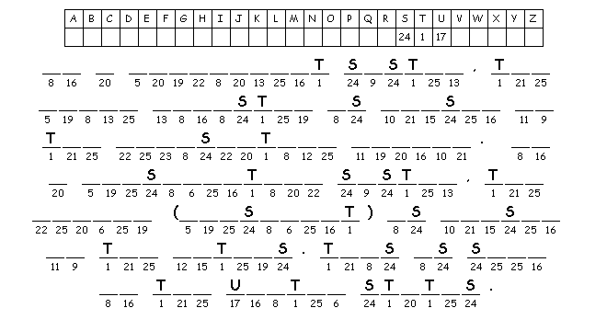
Falling Phrases
Instructions: The letters for each box have fallen down. Use the letters underneath each row of boxes to create words, and ultimately, a full message. (In the first row, the G will move up; in the second row, either the O, C, or M will go next to the G; use clues to determine what letter comes next). Hint: Look for one and two letter words and solve those first!

Types of Government???
