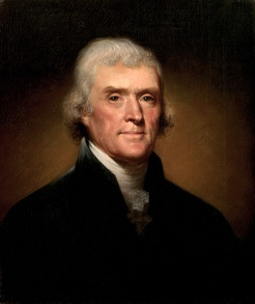
The Jefferson Administration
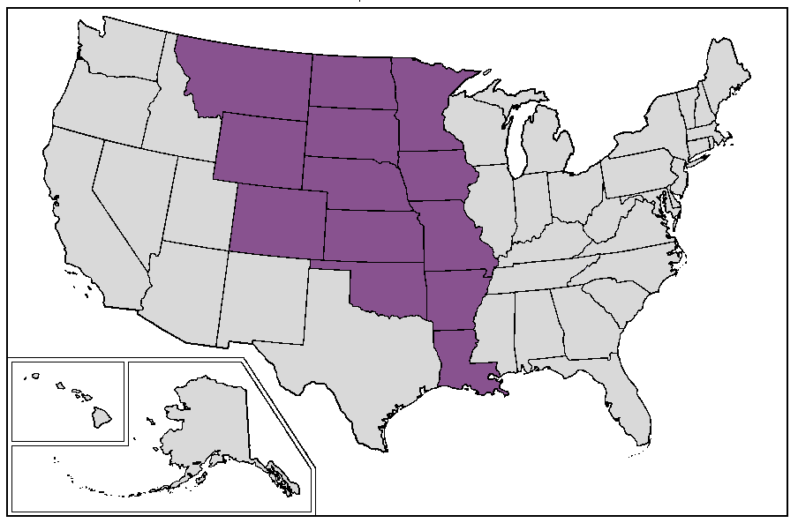
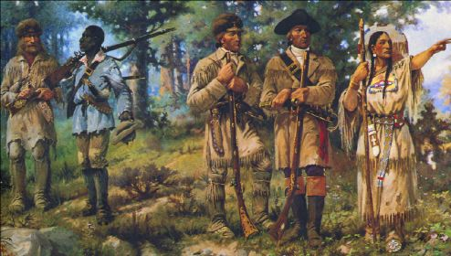
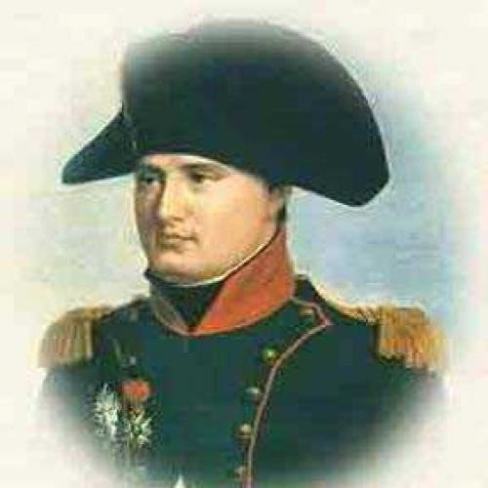
When Thomas Jefferson won the election of 1800 as an Anti-Federalist, his main goal was to reduce the size of the national government. Instead, he did the exact opposite. During Jefferson’s presidency, the power of the presidency, as well as the size of the nation, grew significantly.
In the early 1800s, France had become the world’s most powerful nation, under the leadership of Napoleon Bonaparte. During the time that Napoleon was in power, Spain had given the New Orleans/ Louisiana territory back to the French. At first, Americans feared this. Napoleon had plans of sending French troops over to that territory in hopes of building his empire in North America. This did not happen. Instead, Thomas Jefferson sent James Monroe and Robert Livingston to France to negotiate a deal with Napoleon.
These men were surprised when Napoleon offered to sell them the entire Louisiana territory for just $15,000,000 (Three cents per acre)! Now, Jefferson was supposed to go through Congress to request permission to purchase the territory, and Congress may very well have denied his request. Knowing that a deal like this wouldn’t last long, Jefferson (who wanted to limit the power of the President) bypassed Congress and made the deal anyway, thereby increasing the power of the Presidency. The deal was too good to pass up, and it doubled the size of the United States.
After purchasing the territory, Jefferson sent two army veterans to explore the newly acquired territory. The two men to lead the expedition were Meriweather Lewis and William Clark. Lewis and Clark were looking for a water route to the Pacific Ocean, as well as exploring the unknown territory. Along the way, they were helped out by a Native American woman, Sacajawea.

