Going Global Video Notes – Systems of Government
Directions: Complete the notes on ‘systems of government.’ Before watching the video, write a ‘U,’ ‘C’, or ‘F’ beside each answer in the ‘prediction’ box, predicting which category each descriptor will properly fit into. During the video, write the correct letter for each descriptor in the ‘actual’ column. Following the video, go through each one and write it in the appropriate box.
Systems of Government

What is the purpose of a system of government? | Helps to work together to manage laws and decisions
System of Government | Description | Examples
Unitary (2)
Confederation (3)
Federation (3)
Word Bank
Prediction | Description | Actual
 | Central government has some authority over states, but states also have power
 | Usually formed to meet a specific need (defense; form a common currency)
 | States share powers and functions with a strong Central government
 | One central government makes decisions that affect all people
 | Smaller political units have very limited power, but the Central government is the main authority
 | Group of loosely allied states
 | Each state has its own leaders as well as leaders it sends to the central government
 | Central government is weak and only has certain powers that the states give it
Prediction | Examples | Actual
 | United States, Canada, Russia
 | Many nations in Europe and Africa
 | United States under the Articles of Confederation and the Confederacy during Civil War
Further research on Systems of Government:
Unitary Governments:
Gross Domestic Product (GDP) is a measure of a country’s economy. You will learn more about this in the next unit. For now, research which five UNITARY countries have the largest GDP. Use the link below to find the information: https://en.wikipedia.org/wiki/Unitary_state
Following that step, use the link below in order to determine which type of government each country has. http://www.mapsofworld.com/thematic-maps/types-of-governments.html. From there, conduct your own research to determine if that type of government is authoritarian or democratic.
Country | Type of Government | Description (Authoritarian or Democratic)

Based off of this chart, does a unitary system (in which power is concentrated in one place) mean that a government is authoritarian?
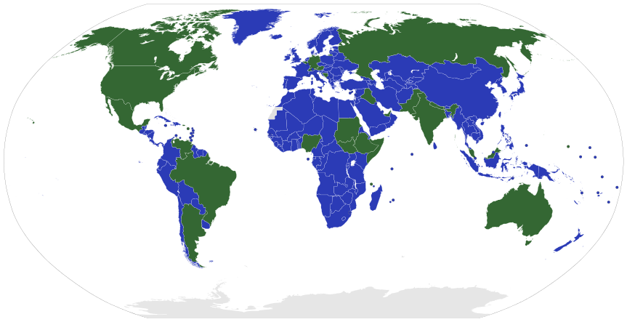
Unitary and Federation States throughout the World
Unitary Systems – Blue Federal Systems - Green
Picture source: https://en.wikipedia.org/wiki/Federation#/media/File:Map_of_unitary_and_federal_states.svg
- What do you notice about the number of unitary states throughout the world compared to the number of federal states?
- What do you notice about the number of Confederations in the world?
- Looking at Europe, Africa, and Asia (not including Russia), are most areas a unitary system or federal system?
- Looking at the Americas, is most of the land area a federal system or unitary system?
- Look at the countries that are larger in terms of land mass. What observations can you make regarding countries with a larger land mass and the system of government that they have in place?

