Ryan Bayne
Writing Across the Curriculum Assignment

Objective: Students will develop note-taking skills while reading about the Qin dynasty. They will use this information to complete a partner writing assignment and use the peer-editing process.

Step One: Students will read the Qin Dynasty handout and complete the two column notes as they read for main ideas. In the left column, they will record questions. In the right column, they will record answers.

Step Two: In partners, students will share their questions and answers. They will then work to create a writing topic question.

Step Three: Students will work with their partner to write a response to their question, alternating every two sentences.

Step Four: Students will work with their partners to edit and revise their writing assignment three times (as explained on page 3).

Step Five: Students will pair with a second group to read and revise their work before completing a final draft (also described on page 3).
Name: ______________________
Instructions: As you read through “Classical China,” record notes on this two-column chart. The first column is for questions from the text. The second column is for answers to those questions.
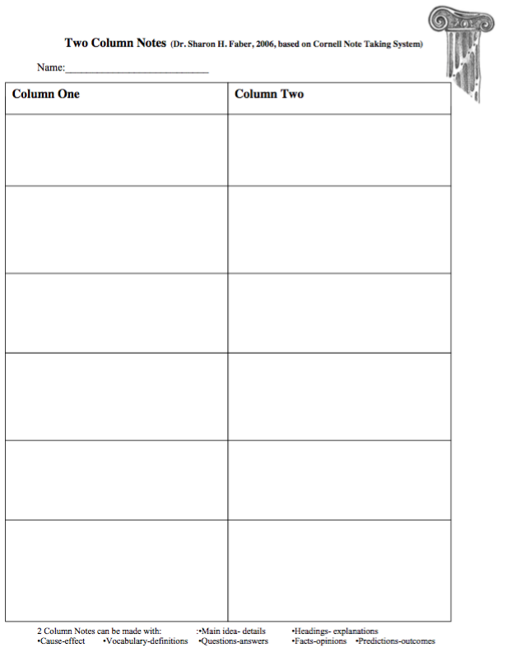
Qin Dynasty Partner Writing
Task: With a partner, share your questions and answers from the two-column notes on the reading assignment. Together, agree on a question to write a response to (example: what was life like during the Qin Dynasty). Answer that question with a topic sentence, and multiple pieces of support from the text!
Instructions:
- Take turns writing, two sentences each. These sentences should include evidence from the text and support the topic sentence.
- Upon completion of the first draft, revise the first draft together. The first person reads the draft aloud while the second person gives feedback for clarity and support.
- Read the draft a second time, with the second partner reading aloud while getting support from the first partner.
- Read through the draft together a third time silently, making any grammatical changes necessary.
- Partner with one other group to repeat this peer revision practice, as modeled in class.
- Finalize your draft and submit it for a grade. Each partner will receive the same grade.

Reading Instructions for Qin Dynasty: As you read the summary of the Qin Dynasty below, record questions and answers from the main ideas of the reading into your two column notes. These notes will be used in your partner-writing assignment!

Qin Dynasty
The Qin Dynasty was the first unified, multi-national and power-centralized state in the Chinese history. It lasted from 221 BC to 207 BC. Although surviving only 15 years, the dynasty held an important role in Chinese history and it exerted great influence on the following dynasties. Only two emperors, Emperor Qin Shi Huang, the first emperor in the Chinese history, and his son ever ruled the state, which was finally overthrown by the people's uprising.

Political History
During the late Warring States Period (476 BC - 221 BC), the state of Qin was in its full development. When Qin Shi Huangdi was in his reign, he defeated the other six states from 230 BC to 221 BC. This ended the chaos caused by wars that had lasted over 500 years. He established a unified and centralized country.
A series of effective measures was been taken during the reign of Qin Shi Huangdi. He contributed much to the development of his country. However, during the late period of his reign, he was cruel and oppressive to his people, and caused dissatisfaction. After he died, his son Hu Hai succeeded him. However, he was so fatuous that he caused the uprising led by peasants of the country. Eventually, the peasants defeated the Army of Qin and swept into the capital which finally ended the Qin Dynasty.
Measures Taken by Emperor Qin
To strengthen the unity of the nation to perpetuate the Qin Dynasty, Emperor Qin carried out many reforms in politics, economy, military affairs, and culture.
In politics, he declared himself the Emperor of the state. All major powers including politics, economy, military affairs were in his hand. Executive organizations both in the central and local places were systematically reorganized and local counties were restructured.
In his economy, he standardized weights and measures and he stipulated that the round coin with square hole should be the coin used in the country.
In addition, he standardized the written character, making the Qinzhuan the standard font. He also placed great importance on infrastructure: irrigation works and road building projects. The miracle of the world, the Great Wall of China, was built under his order. All that he achieved had promoted the development of Qin's economy.
Emperor Qin Shi Huang was a tyrant despite his contributions to the country. To prevent his people to think freely, he burnt many books which he feared would affect people's thinking. Worse, in his second year, after he learnt some scholars' discussions about his arrogance, he buried 460 of them alive. In history, these two events are called 'To Burn the Books and Bury the Scholars Alive'. And yet, at the same time, he ordered to build luxurious palaces, the Great Wall, the famous Terra-Cotta Warriors and Horses, together with his own mausoleum, by imposing on the masses, through hard labor, heavy taxes, and rigorous law and military service, giving the community a difficult and arduous existence.
Source: https://www.travelchinaguide.com/intro/history/qin/

