Immigration Cartoons
From U.S. History
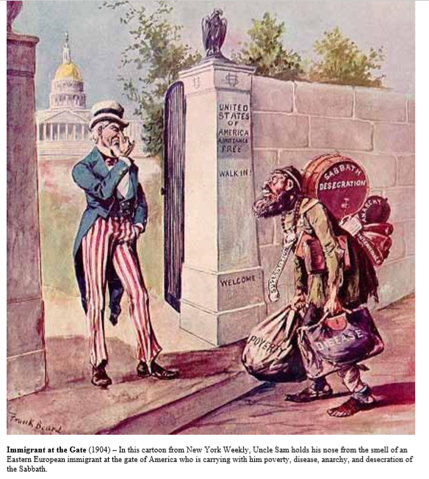
Cartoon A:
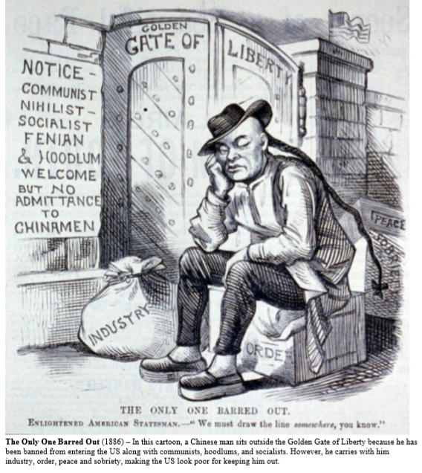
Cartoon B:

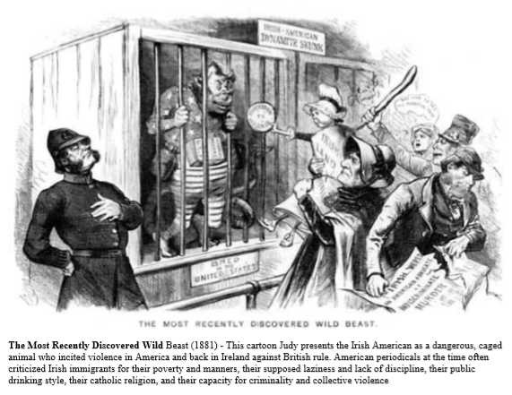
Cartoon C:

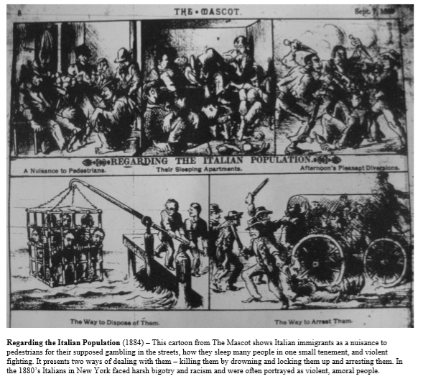
Cartoon D:

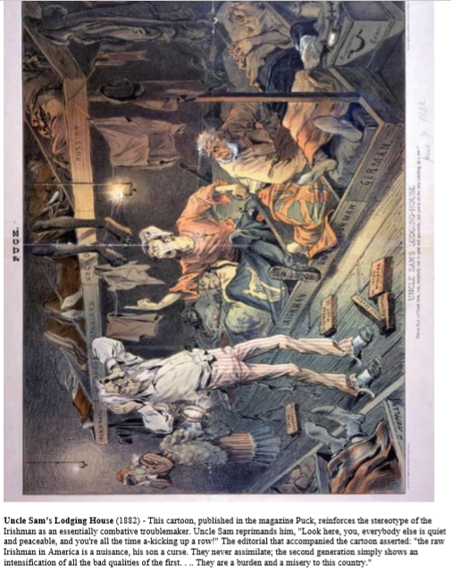
Cartoon E:
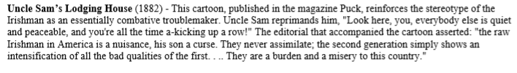
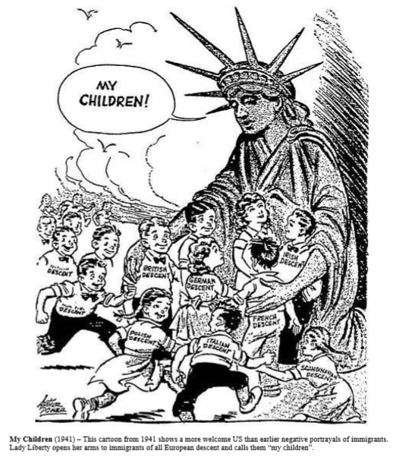
Cartoon F:
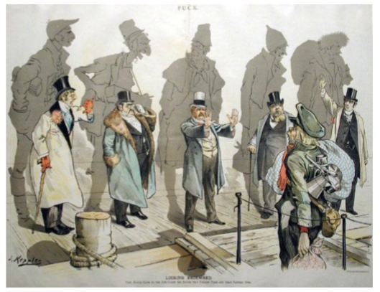
Cartoon G:
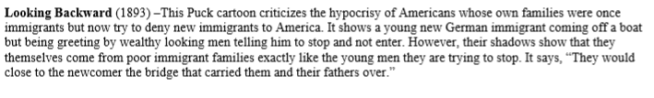

Cartoon H:
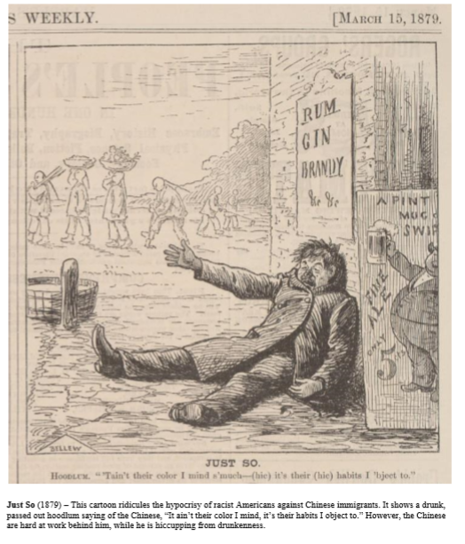

Name: ___________________________________
Activity One - Warmup: Video Notes
Instructions: As you watch the video clip from the New York Documentary, record five notes that you learn about immigration:
Video clip: Immigration (11 minutes, 21 seconds).
1.
2.
3.
4.
5.
Activity Two – Immigration Cartoons through History
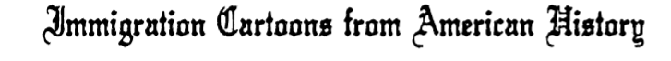
Instructions: With your partner, look through each of the political cartoons regarding immigration. Find each cartoon under ‘Cartoon Title’ and record the year; the group of immigrants the message targets; whether or not it was pro (for) or anti (against) immigration; and an analysis of the message.
Cartoon Title | Year | Target Group of  Immigrants | Pro or Anti  Immigration | Analysis/Explanation
Just So
Recently Discovered Wild Beast
Uncle Sam’s Lodging Housing
Only One Barred Out
Looking Backward

Immigrant at the Gate
My Children

Activity Three - Video Notes
Instructions: As you watch the video clip from the New York Documentary, record five notes that you learn about immigration:
Video clip: A Huge Human Tide (11:21-23:07).
1.
2.
3.
4.
5.
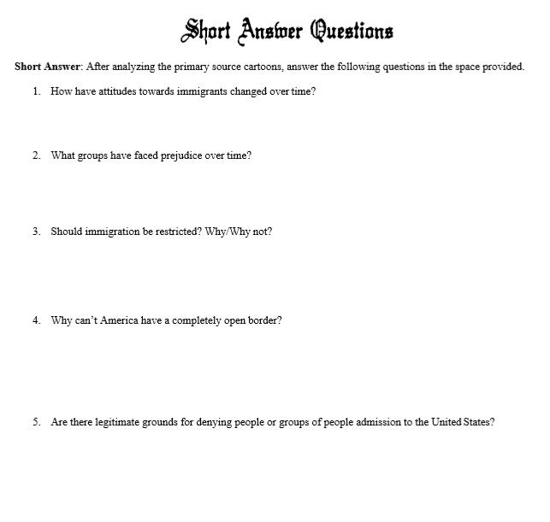
Activity Four: Short Answer questions (independent)

