Name: _________________________________
Below is the plan for the unit on Early National Period. Lessons/assignments are subject to change, but this should give every student an idea on what to expect in the coming days!
Unit: Early National Period
Date | Lesson/Topic/Assignment | What is due?
Day one: | - Warmup Questions  - Quiz on Constitutional Convention  - Video | - Notes – Election of 1800  - Notes – Louisiana Purchase
Day two: | - Warmup Questions  - Discussion: Election of 1800/Louisiana Purchase  - Notes – Three Supreme Court cases
Day three: | - Warmup Questions  - War of 1812 notes  - Vocab Terms
Day four: | - Warmup Questions  - Unit VOCAB QUIZ (not test)  - Benchmark Test | -Vocab Terms  -2 unit questions due  -Vocab Quiz  -Benchmark Test
Unit Questions:
- Despite being an anti-Federalist (small government), explain how Thomas Jefferson actually greatly expanded the role of the national government.
- Who was right in the Marbury vs. Madison case – John Adams in wanting his judge appointed, or Jefferson/Madison for not appointing the judge? Explain your reasoning as well as circumstances of the case.
- Explain the ruling from McCullough vs. Maryland – “the power to tax is the power to destroy.” What does this mean, in reference to the case? Explain the case in detail.
- Explain the causes of the War of 1812, the events that occurred during the war, the Treaty of Ghent, and describe how it made Andrew Jackson a hero.
- BONUS: Why did Alexander Hamilton and Aaron Burr have the feud that they had?
Warmup Questions
Day one

Day two

Day three

Day four

Day five

Name: _________________________________ A New America, part one - Unit terms
Election of 1800-
Midnight Judges –
Alien & Sedition Acts –
Louisiana Purchase –
Sacajawea –
Lewis and Clark –
Hamilton / Burr dual –
John Marshall –
Marbury vs. Madison –
McCullough vs. Maryland --
Gibbons vs. Ogden –
War of 1812-
Francis Scott Key-
Impressment-
Treaty of Ghent-
Burning of the Capital-
Battle of New Orleans-
Monroe Doctrine-

The Election of 1800
- John ________________ administration
  - Elected in 1796 over ____________________ (Vice President)
  - Tried to follow G. Washington’s example
  - Kept Washington’s ___________
  - Becomes unpopular with his “____________________ Acts” (1798)
- The Election of 1800
  - First election with official political parties
  - The Federalists
    - John ____________________ and Thomas Pinckney
    - ____________national government and ____________economy
    - Supported by: ____________, city-dwellers, the ____________
  - The Democratic Republicans
    - Thomas ____________________ and Aaron ____________________
    - ____________ national government and ____________economy
    - Supported by: ____________, artisans, the ____________
  - Adams hurt by lack of support from Alexander ____________
  - Jefferson hurt by accusations of being a ____________
- Election results
  - ________________________wins the popular vote but not a majority in the ____________college
  - Electoral college: Jefferson 73, Burr 73, Adams 65, Pinckney 64, John Jay 1
  - ________________________must decide who becomes President
  - Alexander Hamilton (House of Rep. member) despises ____________and gives support to ___________
  - ________________________becomes our 3rd President
  - ________________________marks the first time presidential power was ____________passed from one ________________________to another
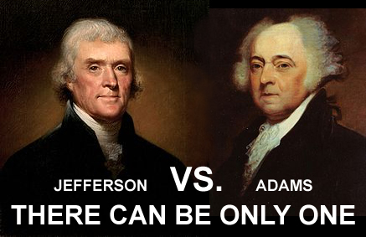
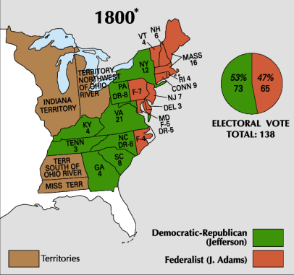
  - Election of 1800 causes the passing of ________________________Amendment

The Jefferson Administration

Thomas Jefferson’s administration
  - Main goal is to ___________________ the size of government.
  - Jefferson is a ____________________________, meaning he wants weaker national gov’t.

The Louisiana Purchase
  - Spain gives New Orleans to ___________ and the ___________
  - Americans fear Napoleon will try to build an empire in North America
  - T. Jefferson sends James Monroe & Robert Livingston to make a deal with _______________
  - Napoleon sells all of France’s territory in N. America for $ ____________________
  - The Louisiana Purchase almost ___________ the size of our nation

_______________ and ________________
  - We needed to explore newly acquired territory
  - Jefferson chooses ___________ ___________ to lead an expedition
  - Lewis & Clark are looking for a ___________ ___________ to the ___________
  - Lewis & Clark are guided by ______________________
  - Lewis & Clark never find the ___________ passage

Alexander ___________ & _________________
  - ___________ blocked ___________ from becoming governor of N.Y.
  - Burr challenged Hamilton to a ___________
  - Burr shoots and kills Hamilton (July 11, 1804)
  - Death of Hamilton weakens ___________ party greatly.

The role of the judiciary in our government
  - Judiciary Act of 1789 – Congress sets up the federal courts
  - Adams midnight judges - ___________________________________
  - Marbury vs. Madison (1803)
    - Jefferson refused to grant Adams appointments
    - William Marbury sues James Madison (Secretary of State)
    - Chief Justice John Marshall (Virginia) ruled against Marbury
      - The Supreme Court did not have the power to force Madison to deliver the papers
      - Marbury did not follow part of the Judiciary Act of 1789; therefore unconstitutional
      - Judicial review (power of the courts to declare laws unconstitutional)
  - McCulloch vs. Maryland (1819)
    - States do not have the right to tax the federal government
    - “The power to tax is the power to destroy”
  - Gibbons vs. Ogden (1824)

The War of 1812
- Origins of the War
  - The British had been ___________ (kidnapping) Americans and forcing them into the British navy to fight the ___________
  - Our 4th President, James ___________, asks Congress to declare war
- ___________strengths and weaknesses
  - Strengths
    - ___________ advantage
    - Clear war aim

Weaknesses
    - Small ___________
    - No ___________
    - No ___________
- British strengths and weaknesses
  - Strengths
    - Large ___________
    - Well-organized army
  - Weaknesses
    - Fighting in a far away land
    - No ______________________
- The land war
  - Americans try to take over Canada, but are badly ___________
  - The British Burning of ______________________.
    - British end the war with France and turn full attention to America (1814)
    - British navy lands in the Chesapeake Bay and moves on Washington D.C.
    - Burn the ______________________ down; Dolley Madison saves a picture of ______________________
    - After sacking D.C. the British move on ___________
    - Americans repulse the British from Baltimore
    - ______________________writes the “______________________” after watching the battle at Ft. McHenry
- The War Ends

Opposition to the war, “Madison’s war”

The Treaty of ______________________
    - Neither side wanted to continue the war
    - Both countries met in ___________to sign the treaty
    - Maintained the same ___________as before the war
    - Issues of ___________and American ___________were not resolved

The Battle of ______________________
    - Fought after the war had ended
    - ______________________led American troops in an annihilation of the British
    - ___________ British casualties; ___________ American casualties

Marbury vs. Madison, 1803
The case: As John Adams was in his final days as president, he signed off on several judges to work in federal courts. These judges, called the ‘midnight judges’ because they were signed in the final hours of Adams’ presidency, were all federalists and shared similar ideas with John Adams.
Thomas Jefferson, a Democratic-Republican, did not want these judges to be appointed, so his secretary of state, James Madison, did not send off the signed paperwork to Congress for approval.

One of the approved judges was Federalist William Marbury. Adams had approved Marbury to be a federal judge in D.C. However, since Madison refused to send the paperwork, Marbury did not get his position. Marbury took his case directly to the Supreme Court.
Who was right in this case—Marbury or Madison, and why?
Marbury’s argument:  - | Madison’s argument:  -
Chief Justice John Marshall looks at this case and has to see how it applies to the Constitution...
First, he decides, the president does have the power to appoint Federal Judges.
- What article of the Constitution would say this?
- If the Constitution states that the President had the power to appoint federal judges, did James Madison have the right to refuse to send the paperwork?

Second, John Marshall has to look at the background of the case. First, he considers the Judiciary Act of 1789. This act states that all cases must go through the lower court system, as well as the Court of Appeals before they reach the Supreme Court. However, Marbury brought this case directly to the Supreme Court to be heard. Cases can only go directly to the Supreme Court when states are directly involved.
Now, consider these questions:
- Which branch of government would have created the Judiciary Act (it’s an act, or law):
- Was it legal for Marbury to bring his case directly to the Supreme Court?
Why or why not?
Based on what Marbury looked at in this case, (#3 and #4), what do you think the result was?
Actual Result:

McCullough vs. Maryland, 1819
In 1816, Congress set up the First National Bank in Philadelphia. By having a national bank, the federal government could easily raise a significant amount of money to help run the country. While the national bank was good for the federal government, it could have run a lot of state-run banks out of business, thereby cutting into the money that states have to spend on their own governments.

By 1817, the Second National Bank was set up in Baltimore, Maryland. The Maryland State government, in an effort to run the national bank out, passed a bill stating that all non-Maryland chartered banks would have to pay extremely high taxes. This would help compensate for some of the lost money.
The leader of the national bank, David McCullough, refused to pay the tax, and fought against the state of Maryland. The case went to the Supreme Court.
Who is right in this case? McCullough & the national bank, or Maryland & the state banks?
Why McCullough should win…  -  - | Why Maryland should win…  -  -
Chief Justice John Marshall goes to work again…
- He looks at the case…the national bank was set up by Congress, which was allowed. This is allowed because of which article in the Constitution?
- Secondly, if the bank was constitutionally created, are states allowed to tax it? Use the Constitution to support your argument.

What do you think the result should have been, and why?
Actual Result:

Gibbons vs. Ogden, 1824
Two steamboat ferry operators were operating in New York City. One of them, belonging to Aaron Ogden, had been granted an exclusive license to navigate that territory by the state of New York (where he was navigating). The second, owned by Thomas Gibbons, soon started to navigate between New Jersey AND the same area in New York city, claiming that trade between two states (interstate commerce) is something that only the federal government (Congress) has the power to dictate, not state governments. Aaron Ogden and Thomas Gibbons began to argue over who should be allowed to navigate in the waters of New York City.

The two men, once business partners, now enemies go through the courts and the case reaches the Supreme Court in 1824.
Who is right in this case? Aaron Ogden, who has an exclusive license from New York, or Thomas Gibbons, who argues that only federal law can dictate interstate commerce?

Why Ogden should win… | Why Gibbons should win…
Chief Justice John Marshall is at work once more…
- What is the first thing he should look for in this case?
- Where parts of the Constitution do you think will help him?
- What group has the power to dictate interstate commerce?
Who do you think will win this case and why?
Actual Result:

The Constitution
Article 1 – Legislative Branch (Congress)
Article 2 – Executive Branch (President)
Article 3 – Judicial Branch (Court system)
Article 4 – Creating new States (process)
Article 5 – Amendment Process
Article 6 – “Supreme Law of the Land” – nothing can go against what the Constitution allows.
Article 7 – How to ratify the Constitution

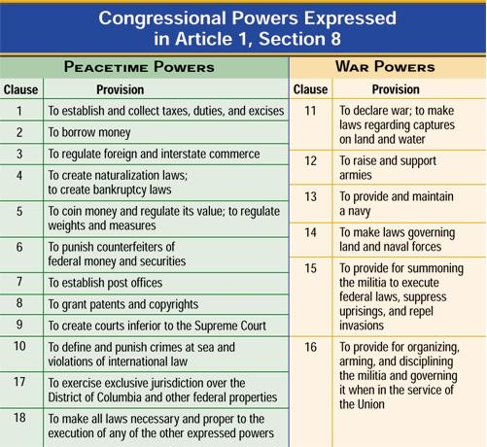
Powers of Congress (from Article 1) and the President

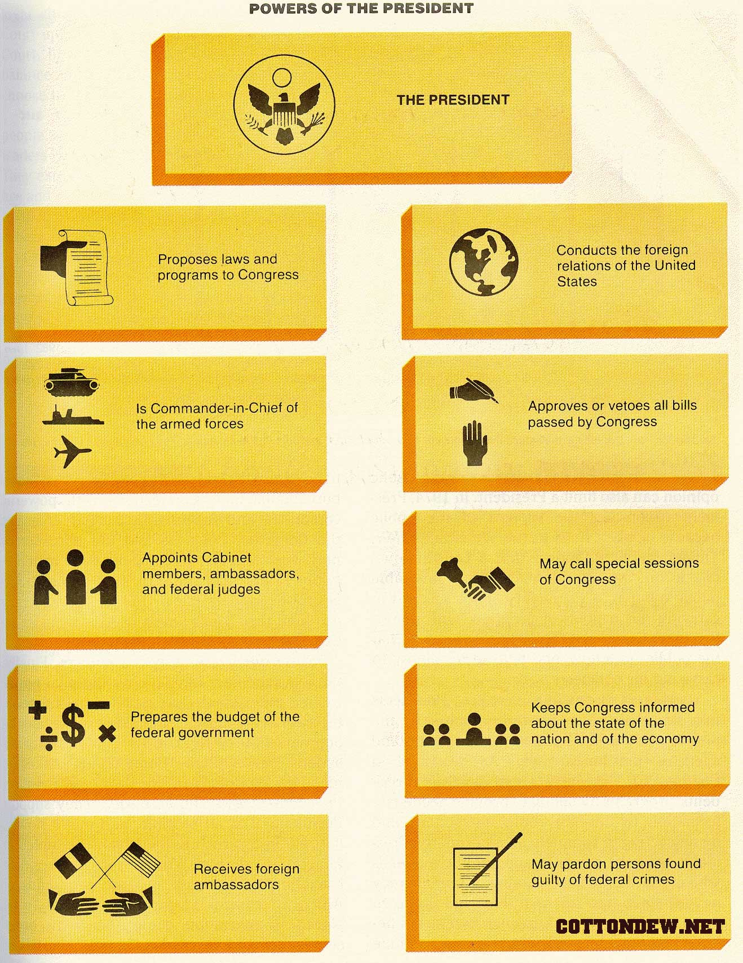
Name: ___________________________________ The War of 1812
Complete the notes and questions below by watching “Hip Hughes: Constitutional Convention,” located on mrbayne.com (under “Early National Period).
I. Cause One: _________________________________________________________
- Why trade restrictions?__________________________________________________________
- What are “impressments?”__________________________________________________________
II. Cause Two: ________________________________________________________
- Tecumseh: __________________________________________________________
- Who was supplying Native Americans with weapons? __________________________________
III. Cause Three: _____________________________________________________________
- What country did the U.S. consider annexing? ________________________________
IV. Cause Four: ________________________________________________________________
- Democratic-Republicans supported: _________________
- Federalists supported: ________________________
- T/F: The vote for this war was the closest in American history: ______________
- Was New England FOR or AGAINST the war? _____________
V. Cause Five: Lack of _________________________________________________________
A. What had the British gotten rid of before American declared war: ________________________
Events of The War of 1812
VI. Where the war begin: _______________________________
- Overall, very successful or barely successful: ______________________
- Which person did they defeat in this area: __________________________
VII. The Coastal Front
- August 24, 1814, what city is invaded: __________________________________
  - ______________________________________________________________________
  - What got the British out of this city? _______________________________________________
- Where did the British go next? ____________________________________________
  - Fort McHenry: ________________________________________________________
  - Francis Scott Key: _____________________________________________________
- Mid 1814, what two countries sign an alliance: _______________________________________
- What treaty ended the War of 1812 (in 1814): _____________________
  - Why did the biggest battle of the War of 1812 occur after this treaty? ______________________________________________________________________
VIII. The Battle of ________________________
- Andrew Jackson: __________________________________________________________
Review questions:
1. Why did the War of 1812 take place?
2. What is ‘impressment’?
3. How did a lack of communication play a huge part in this war?
4. Why did the Battle of New Orleans take place after the war was already over?

