Ryan Bayne

Strategy Used: Bio-Pyramid
Reading Assignment: Confucius Biography

Objective: Students will understand the teachings of Confucius, as well as the contributions he made to China culture.

Tasks:
- Students will be given the biography of Confucius to read. As they read, they will record notes in the right-hand column of the page on the main ideas from each section. Additionally, they will underline or highlight the supporting evidence from the passage in the left column.
- After the reading is complete, students will complete the Biopoem on Confucius. They will use information from the main ideas of the reading!

Name: ______________________________ Confucius Bio-Pyramid

Instructions: After reading the biography on Confucius, use the template below to complete the Bio-Pyramid on the life of Confucius! As you complete this Bio-Pyramid, use information you recorded from the main ideas of the Confucius reading assignment!

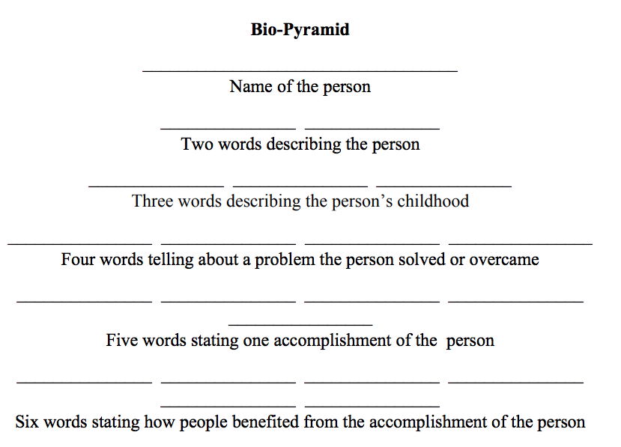
Reading Assignment Instructions: As you read through the biography on Confucius, record the main idea(s) from each section in the column to the left. Additionally, highlight or underline the supporting evidence from the passage.

Confucius: 551 BCE-479 BCE
Synopsis: Confucius was an influential Chinese philosopher, teacher and political figure known for his popular aphorisms and for his models of social interaction.  Kong Qui, better known as Confucius, was born in 551 B.C. in the Lu state of China (near present-day Qufu). His teachings, preserved in the Analects, focused on creating ethical models of family and public interaction, and setting educational standards. He died in 479 B.C. Confucianism later became the official imperial philosophy of China, and was extremely influential during the Han, Tang and Song dynasties. | Main Idea(s) from section (highlight evidence in the passage):
Early Life  Confucius, also known as Kong Qui or K’ung Fu-tzu, was born probably in 551 B.C. (lunar calendar) in present-day Qufu, Shandong Province, China. Little is known of his childhood. Records of the Historian, written by Ssu-ma Chi’en (born 145 B.C.; died 86 B.C.) offers the most detailed account of Confucius’ life. However, some contemporary historians are skeptical as to the record’s accuracy, regarding it as myth, not fact. According to Records of the Historian, Confucius was born into a royal family of the Chou Dynasty. Other accounts describe him as being born into poverty. What is undisputed about Confucius’ life is that he existed during a time of ideological crisis in China. | Main Idea(s) from section (highlight evidence in the passage):
Philosophy and Teachings  During the sixth century B.C., competing Chinese states undermined the authority of the Chou Empire, which had held supreme rule for over 500 years. Traditional Chinese principles began to deteriorate, resulting in a period of moral decline. Confucius recognized an opportunity—and an obligation—to reinforce the societal values of compassion and tradition. His social philosophy was based primarily on the principle of "ren" or "loving others" while exercising self-discipline. He believed that ren could be put into action using the Golden Rule, "What you do not wish for yourself, do not do to others." (Lunyu 12.2, 6.30).  Confucius’ political beliefs were likewise based on the concept of self-discipline. He believed that a leader needed to exercise self-discipline in order to remain humble and treat his followers with compassion. In doing so, he would lead by positive example. According to Confucius, leaders could motivate their subjects to follow the law by teaching them virtue and the unifying force of ritual propriety.  His philosophy of education focused on the "Six Arts": archery, calligraphy, computation, music, chariot-driving and ritual. To Confucius, the main objective of being an educator was to teach people to live with integrity. Through his teachings, he strove to resurrect the traditional values of benevolence, propriety and ritual in Chinese society. | Main Idea(s) from section (highlight evidence in the passage):  Main Idea(s) from section (highlight evidence in the passage):
Major Works  Confucius is credited with writing and editing some of the most influential traditional Chinese classics. These include a rearrangement of the Book of Odes as well as a revision of the historical Book of Documents. He also compiled a historical account of the 12 dukes of Lu, called the Spring and Autumn Annals. Lunyu, which sets forth Confucius’ philosophical and political beliefs, is thought to be compiled by his disciples. It is one of the "Four Books" of Confucianism that Chinese philosopher Zhu Xi, a self-proclaimed Neo-Confucian, published as Sishu in 1190. Far-reaching in its influence, Lunyu was later translated into English under the title The Analects of Confucius. | Main Idea(s) from section (highlight evidence in the passage):
Death and Legacy  Convinced that his teachings had not made a significant impact on Chinese culture, Confucius died on November 21, 479 B.C. in Qufu, China, a year after losing his son, Tzu-lu, in battle. His followers held a funeral and established a mourning period in his honor. As of the fourth century B.C., Confucius was regarded as a sage who had deserved greater recognition in his time. By the second century B.C., during China’s first Han Dynasty, his ideas became the foundation of the state ideology. Today he is widely considered one of the most influential teachers in Chinese history. | Main Idea(s) from section (highlight evidence in the passage):

Source:
“Confucius.” Biography.com, 28 Apr. 2017, www.biography.com/people/confucius-9254926.

