Name: _________________________________
Below is the plan for the unit on the Civil War. Lessons are subject to change, but this should give every student an idea on what to expect in the coming days!
 | Unit: The Civil War
 | Date | Lesson/Topic/Assignment | What is due?
 | Day one: | - Warmup Questions  - Notes – Battles & Leaders  - Vocab/Unit Review
 | Day two: | - Warmup Questions  - Notes – Major Battles  - Vocab/Unit Review
 | Day three: | - Warmup Questions  - Unit Vocab/Finish notes/Finish unit review
 | Day four: | - Warmup Questions  - Unit Test
Warmup Questions
Civil War Vocabulary
1. Ft. Sumter
2. First Battle of Bull Run
3. Casualty
4. George McClellan
5. Ulysses S. Grant
6. William T. Sherman
7. Robert E. Lee
8. Thomas “Stonewall” Jackson
9. The Monitor and the Merrimack
10. Frederick Douglass
11. Battle of Fredericksburg
12. Battle of Chancellorsville
13. Battle of Antietam
14. Battle of Gettysburg
15. Battle of the Wilderness
16. Battle of Spotsylvania
17. Emancipation Proclamation
18. Gettysburg Address
19. Foreign recognition
20. Contraband
21. Sherman’s March to the Sea
22. Appomattox Court House

Civil War Battles and Leaders
I. _____________________ is elected as our __________President in November __________
A. __________is Imminent! Why would __________States __________?
- __________the new administration would pass laws to __________ __________
- Wanted to prove that states were ____________________ (could rule themselves)
- Felt they were not ____________________in our ____________________
- For the same reasons our ____________________fought the ____________________
II. Secession of the ____________________States
- Before Ft. Sumter: ____________________, Mississippi, Florida, Alabama, Georgia, Louisiana, Texas
- After Ft. Sumter: __________, Arkansas, Tennessee, North Carolina
C. ____________________States (held slaves, but did not secede)
1. Delaware, Missouri, Maryland, Kentucky

III. Civil War __________

A. __________Generals

______________________________
a. ____________________Graduate; worked as store clerk at start of war
b. Went on to become the ______________________greatest general
c. Became 18th ______________________of the U.S.
- William Tecumseh ___________
a. Pursued a “______________________” policy
b. Led the “_________________________________” in Atlanta
c. The most ______________________of ___________generals in the South
3. George ___________

a. Commanded the Army of the ___________
b. Cautious due to the loss at ______________________
c. Fired due to his “____________________________________________”
- Ran for president against ______________________ (1864)
B. ___________Generals
1. Thomas “___________”___________

a. Hero of First ___________ (Battle of Bull Run)
b. ___________Fanatic
d. Rode to battle with an arm up to ‘_________________________________’
2. ______________________

a. One of the top ___________minds in our country
b. ___________to be the head general in the ___________Army (declined)
c. Forced to decide where his ___________lied; led the army of _____________for Confederacy

IV. ___________and Weaknesses
A. ___________Strengths:
1. Larger ___________; More ___________; More ___________; Previously established ___________
B. ___________Strengths
1. More experienced ___________; Fighting a ___________war; Fewer big ___________to defend
V. Union and Confederate ___________
- The ___________: ___________Strategy-War of ___________ (fight until North wears down)
- The North: ___________Plan (surround South from all sides and strangle them)
VI. The First Shots are Fired
A. ______________________

1. ___________, S.C. ,
___________16, ___________
B. Robert Anderson (North) vs. PGT Beauregard (South)

VII. Battle on the Sea

A. ___________vs. ___________
- The Confederate ___________ (The Virginia) is confronted by the Union ___________off the coast of Virginia
- First battle of ___________ships
- Ended in a ___________; made ___________ships ___________
VIII. Major Battles

A. First ___________/______________________

1.Fought 25 miles outside of ___________D.C.
2.Union General ______________________led 35,000 troops against equal ___________forces
3.Confederate leader _________________________________acquires his nickname here
4. ___________troops start strong, but are later ___________by ___________army
B. ______________________
1.General ___________was trying to mount a ___________attack on Washington D.C.
2.George ___________discovered his plans and attacked him along ___________Creek in Sharpsburg, ___________
3.Single ___________day of the war (26,000 casualties)
4.Defeated Confederates lost all hope of ______________________intervention
- ______________________Proclamation

1.Lincoln’s issues after the victory at ______________________ (Jan. 1, 1863)
2.Freed the slaves located in “______________________” states
3.Made the destruction of ______________________a Northern war aim
4. ______________________ ______________________intervention

D. The Battle of ___________________________
1. ___________________ was fired for being too slow
2Union forces cross the Rappahannock and attack Robert E. Lee

3. Robert E. ____________ was in a well defended position
4. The ______________ army cuts down Union troops at from the Sunken Road at the base of Marye’s Heights
E. ________________________ (April 1863)
1.George McClellan is replaced by Ambrose Burnsides who is soon defeated by Lee at Fredericksburg
2.Joseph Hooker then replaces Burnsides and confronts Lee at ______________________
3.The Confederates win at Chancellorsville but suffered a great loss: __________________________’s death
- ________________________________
1.Most well-known battle ever fought on American soil
2.July 1-3, 1863
3.Considered the ___________________________________________
4.Union losses: 23,000
5.Confederate losses: 22,000
6.Confederates lose; Last time ______________________ forces would seriously threaten the North
- The Gettysburg Address

1.Speech delivered by ________________________ to dedicate the memorial cemetery
2.Lincoln’s most famous __________________
3.Outlines the ____________________ and meaning of the war
4.States that the Union will never ___________________________

- ______________________
1.Strategic outpost on the Mississippi River
2.Necessary for the North to enforce “__________________ plan”
3.__________________ first great victory
4.Grant acquires the nickname “____________________________” Grant
- _______________________ March to the Sea
1.Grant sent Sherman to march through the South __________________ everything in his path
2.Left supply lines and lived off the land
3.This was Sherman’s “__________________” concept
- _____________ Vs. _______________
1. Lee’s forces are greatly diminished after ____________________
2. Grant is put in charge of the Army of the Potomac
3. Grant moves on _______________________
- Lee intercepts Grant near the Chancellorsville Battlefield
K. The Battle of the Wilderness
1. Union and Confederate forces clash in the woods near the Rapidan River
2. Lee defeats Grant, but Grant does not _______________
- Grant presses on towards _________________
L. The Battle of ____________________

1. Lee’s forces race to intercept Grant
2. Second confrontation occurs near Spotsylvania Court House
3. A two-week battle ensues
4. Lee is only able to slow Grants progress towards Richmond
M. The Battle of ______________________

1. Lee and Grant battle again __________ miles outside of Richmond
2. Becomes one of the _____________________ battles of the war
- Lee holds off Grant, but is badly weakened
- Grant earn his nickname “_______________________”

IX. The South’s chances head South

A. ___________________ is reelected (1864)
B. Lee surrenders to ________________ at ____________________ on April 9, 1865
C. Lincoln is shot on _________________, 1865

The Civil War
Of all the elections in our country’s history, the Election of 1860 was perhaps the most important. This election featured Republican candidate Abraham Lincoln against a man named Stephen Douglas. Lincoln, opposed to slavery, won the election. The South was very concerned that after Lincoln won, he would try to get rid of slavery, a right they thought belonged to the states.

After Lincoln won the election, South Carolina seceded, or left the country. They were followed by several other states, forming the Confederate States of America. Jefferson Davis, a former Senator from Mississippi, became the first (and only) president of the Confederacy.

The Civil War began in April of 1861, when Confederate forces launched a small attack on Fort Sumter in South Carolina. Fort Sumter, a Union (Union = Northern troops) controlled fort that was in the South, was in desperate need of supplies. When Union ships arrived to deliver supplies, the President of the Confederacy, Jefferson Davis, ordered his Confederate ships to fire upon the Union ships. After 34 hours, the standoff had come to an end with the Union (North) surrendering the battle. Nobody was hurt, nobody died. But the Civil War had started, and this would be the only battle in which nobody died.

An advantage that the North had during the war was its major industries and its extensive railroad system, making it way easier to transport supplies and troops. In addition, communication systems in the North were much better, especially after the development of Morse code. The North was also better organized. The South, however, had very good leadership (men like Robert E. Lee), and they were fighting mainly in their homeland, where they knew the land better.

This was evidenced at the first major battle, called the First Battle of Bull Run. Here, the North started on the offensive, and it looked like it would be a short, one-sided battle. Southern General Stonewall Jackson, however, ordered his men to stand tall against the attack, like a “stone wall” (from where he earned his nickname). His men did just that, and eventually pushed the Northern troops back, defeating them and pushing them all the way back to Washington. This battle stunned the North, and made them realize that it would be a long, deadly war.
As the war continued, the fighting became worse and worse. The South had plenty of early success against the North, and eventually went into Maryland, where Lee’s invasion was going well. At this point, however, a copy of his invasion plans fell into the hands of Union General George McClellan. McClellan was able to prepare for Lee’s oncoming army, and met them at Antietam Creek, in Sharpsburg, Maryland, where the Battle of Antietam took place. On this day, September 17, 1862, America had the “bloodiest day” in their history of warfare, where over 22,000 men were either killed or wounded in a single day before Lee’s Confederate troops were finally pushed back.

Following Antietam, Lincoln wanted to provide a spark to keep the Northern troops going, and that came with his ‘Emancipation Proclamation’ on January 1, 1863. In this, he stated that all slaves in rebelling areas (the South) now have their freedom. In the neutral states (states that were on neither side), it said nothing about slavery ending; Lincoln wanted to ensure that those states would not turn against him. But according to this, in Southern states, slavery was now banned. Of course, the South had seceded, so they were not going to listen to this, and slavery continued. However, this gave the North motivation to continue fighting, and a cause to fight for. Additionally, it meant that if the South lost and re-entered into the U.S., they would not be allowed slavery. Also, most foreign countries were against slavery; now, foreign countries were not likely to interfere and help the South. Finally, this allowed for the enlistment of African American soldiers into the Union army!

By 1863, the war had taken place almost exclusively in the South. Lee wanted to take his Confederate Army and invade the North. He e did this at Gettysburg, with an army of 75,000 men. After three days of intense fighting, including the famous “Pickett’s Charge” in which Major General George Pickett sent his men charging up the battlefield only to be slaughtered (10,000-15,000 men died in this), Lee eventually ended up losing, and it would be the turning point battle of the Civil War. Soon after this battle, Lincoln made his famous “Gettysburg Address,” in which he described the Civil War as a struggle to preserve (protect) a nation that was dedicated to the proposition (idea) that all men are created equal. Lincoln believed that America was ONE nation, not a collection of separate states, and did not believe that states could freely join and leave. They must stay united, and his goal was to preserve the Union.

While all this was going on in the North, fighting was occurring in the South. William T. Sherman made his famous “March to the Sea” in which he stormed through Georgia with his troops, destroying everything in their paths, and burning cities along the way. Union General Ulysses S. Grant (who later became President) led northern victories at Vicksburg and Chattanooga; by 1864, he began heading towards Richmond, Virginia, the capital of the Confederacy. With a depleted army and lack of resources, Robert E. Lee was forced to surrender to Ulysses S. Grant at Appomattox Court House, about 25 miles east of Lynchburg, Virginia, on April 9, 1865. The Civil War was over.

Now, Lincoln had to come up with a plan to rebuild the country. His plan was called “Reconstruction.” The goal of this plan was to peacefully bring the country back together. In doing this, he did not want to punish the South, but he did want to set certain standards that would not allow for another Civil War. Unfortunately, less than a week after the end of the Civil War, Lincoln was assassinated by John Wilkes Booth.

Across
2 | Former slave, urged Lincoln to enlist African American soldiers
5 | State that Antietam took place in: _____
8 | Name of Lincoln's plan to bring country back together.
10 | Number of people that died in the opening battle of Civil War (at the Fort)
11 | Led famous charge at Gettysburg
13 | The Emancipation Proclamation did not free slaves in the _______ states, because Lincoln did not want them to turn against him.
14 | Major issue going into Civil War
15 | North vs. _______
17 | First state to secede (leave) the Union
21 | General Jackson's nickname that he earned at Bull Run
22 | the Fort where Civil War began: ____ _______
24 | A major advantage of the north was its major ________
25 | Famous 3 day battle of 1863: ____________; Lee lost this; turning point of Civil War
26 | The North had almost twice as many __________ as the South, making transportation easier.
27 | The __________ Proclamation freed slaves in all rebelling states
28 | Gettysburg was the ________ point of the Civil War
Down
1 | Former Senator, President of Confederacy
3 | Location of Lee's surrender: __________ Court House
4 | Month the Civil War began
6 | Bloodiest day took place at Battle of: ___________
7 | _____ code made communication better in the North.
9 | _______ was elected in 1860 (last name only)
12 | ______ (North) vs. Confederacy (South)
16 | _________ __ _______: Union general who led victories in the South when others couldn't; Lee surrendered to him; future President
18 | The _____________ of 1860 was one of the most important ones in US History
19 | _________ __ ____: Southern General of the Army of Northern Virginia
20 | First major battle of the war was the First Battle of _____ ____ in Manassas, VA.
23 | Famous March to the Sea guy (last name only)

Civil War Puzzle

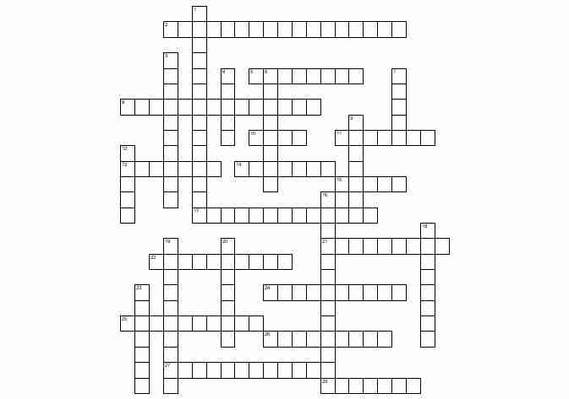

Name:

Civil War and Pre-Civil War Study Guide

1. In what state did the attack on Fort Sumter occur?

2. The Emancipation Proclamation was issued following which battle?

3. What position did Robert E. Lee hold during the Civil War?

4. What was the primary reason Robert E. Lee resigned his Union army position?

5. Where did Robert E. Lee surrender to Ulysses S. Grant?

6. Where were the first shots of the Civil War fired?

7. Which battle is considered the major turning point of the Civil War?

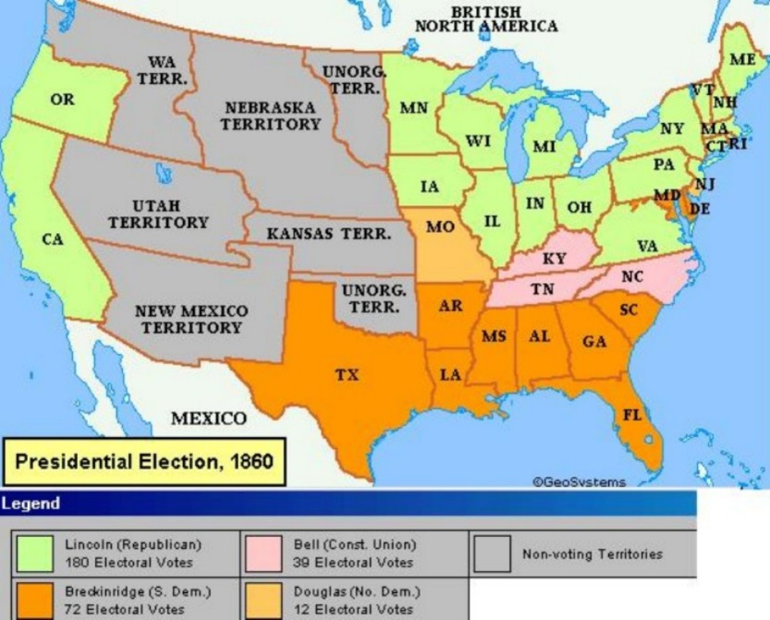
Refer to this picture for questions 8 and 9

8. According to this map what areas of the country supported Lincoln?

9. Why is this map evidence that the election of 1860 was an election of sectional issues?

10. What man became president of the United States as a result of the election of 1860?

11. What occurred immediately after Lincoln's election in 1860?

12. Why did Lincoln believe the Civil War was a "Second American Revolution?"

13. How are the Emancipation Proclamation and the Gettysburg Address similar?

In which areas were slaves freed by the Emancipation Proclamation?

What Northern General went on to become the 18th President?

16. What Southern General received his nickname at First Manassas (Bull Run)?

18. What Northern General was fired for his “case of the slows?”

19. What was the first major battle of the war?

20. At what battle was the single bloodiest day of the war?

21. In what battle was Stonewall Jackson killed?

22. Who was the President of the Confederate States of America?

23. The North’s greatest strength in the Civil War was its:

24. At the beginning of the Civil War, the South seemed to have the advantage of:

25. A major economic difference between the North and the South at the start of the Civil War was:

26. List three things accomplished by the Emancipation Proclamation:
___________________________________________________________________
___________________________________________________________________
___________________________________________________________________

Which side won the battle?
31. Fredericksburg
32. First Manassas (Bull Run)
33. Antietam
34. Gettysburg
35. Chancellorsville

Which side had the advantage:
36 Had a higher population
37. Had fewer bid cities to defend
38. Was fighting a defensive war
39. Used the “anaconda plan”
40. Had more experienced officers

"A house divided against itself cannot stand. I believe this government cannot endure, permanently half slave and half free. I do not expect the union to be dissolved - I do not expect the house to fall - but I do expect it will cease to be divided. It will be all one thing or all the other."
--Abraham Lincoln, 1858
What action reflects Lincoln's views expressed in this 1858 debate excerpt?

"If I could save the union without freeing any slave, I would do it; and if I could save the union freeing all of the slaves, I would do it; and if I could do it by freeing some and leaving others alone, I would also do that."
--President Abraham Lincoln
August, 1862
What goal is consistent with Lincoln's speech quoted above?

America is dedicated to the proposition that "all men are created equal."
* America is ruled by a government "of the people, by the people, and for the people."
* America is "one nation," not a collection of sovereign states
The quotations in the list are all contained in:
41. What abolitionists called for immediate and uncompensated emancipation of slaves in The Liberator?

42. Who wrote the anti-slavery novel entitled Uncle Tom’s Cabin?

43. What did the Missouri Compromise of 1820 do?

44. What were three provisions of the Compromise of 1850?

45. California was entered as a free state under the:
46. To resolve sectional tensions over the expansion of slavery into the West, what established the principle of popular sovereignty

47. The Supreme Court established the principle that slaves were not citizens in the Dred Scott case. This decision determined what three principles

48. Choose the term that best fills in the blank.

South: free trade
North: ________

49. Why were the political compromises that Henry Clay created so important?

50. What was a major result of the Kansas-Nebraska Act?

51. As the U.S. acquired more land between 1803 and 1850, controversy over these territories focused on the--

