Brain Games Season 1 Episode 1 - Watch This Name:
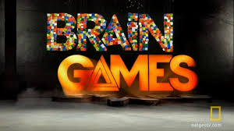

- Illusions tell us that what we’re trying to see is not as the world as it is. We’re actually generating perceptions in our world that are

___________________ to see, and that doesn’t have to correspond with what is actually there.

- The light reflected by an object is converted by your eyes into an

________________ signal that is sent through the optic nerve to the back of your brain.

- What is one of your brain’s best tools to decide how an object is positioned in space?

- When the man is standing with two shadows and one of the white lights has a purple film placed over it, what happens to the other shadow?

- True or False: Color does not exist in the physical world.

- Your brain uses shadow, color, and _______________________ lines to help us learn the position of objects.

- Where in the brain does it use familiar patterns it sees to map out the room around you?

- True or False: Your brain is constantly analyzing motion for indications that danger is present.

- The human brain is hard wired to recognize ______________________ motion - any living motion.

- True or false: Very few people experience pain while watching somebody experience pain, but it can happen.

- Give an example of mirror neurons.

- What percentage of participants weren’t able to feel the pain associated with the fake hand?

- What percent of your brain is devoted to sight?

- Describe the McGurk effect in your own words.

- True or false: Sounds in movies are usually made by other objects then what it looks like.

- Sound is converted by nerve endings in your __________________ ear.

- What is the one sound that the human ear is particularly good at deciphering?

- How does Daniel use echolocation?

- True or False: If you go blind, your visual cortex goes dark.

- True or False: Younger brains are more adaptable than older brains.

