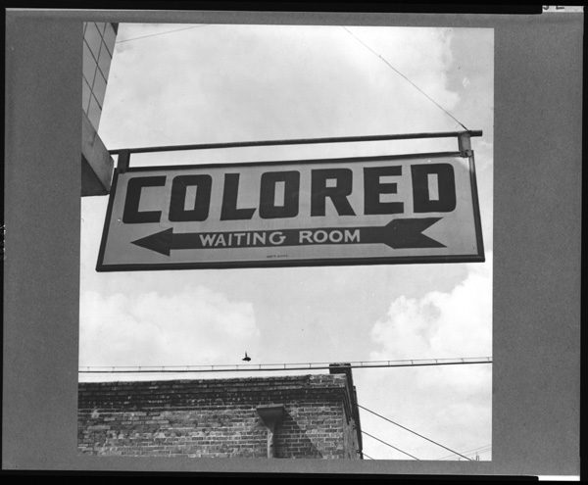
Part one – A time of Change
Many things can be said about America in the later part of the 19th century (1800-1899) and the early 20th century (1900-1999). But one thing remains the same—it was a place of change. Farmers, struggling to get by and hardly earning enough money to support their families, pushed for reform (change). African Americans, long-discriminated against in the South through Jim Crow Laws and Black Codes (which were made legal as a result of Plessy v. Ferguson, 1896!!!), pushed for equality. Many African Americans, seeking to escape the discrimination and poverty in the south, moved to the West (to gain free land via Homestead Act) or to the North (seeking jobs; the Great Migration). The rise in urbanization (people moving to the cities) occurred due to the number of jobs within the city (this is where the factories were). But with the increase in city population came an increase in problems. Filth, disease, overpopulation, crime, fire, and political corruption were everyday problems that the city dwellers had to face. Workers, facing unsafe conditions, low pay, long hours, and even child labor, began to join unions (AFL; Knight of Labor; ARU; ILGWU) to fight for better work conditions and rights. Immigration was very common between 1880 and 1920. This time period saw over 23 million immigrants come into the country, mainly through New York City (Ellis Island). The rise in population led to overcrowded cities and run-down living conditions. Yes, it was a changing place; America was facing problems, and these problems would be addressed by the Progressive Movement, and the Progressive Presidents—Teddy Roosevelt, William Taft, and Woodrow Wilson. America was growing as well.
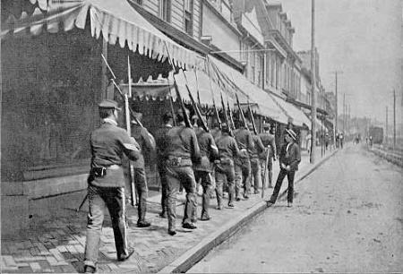
But America was growing as well. From the later part of the 1890s, through the 1900s (20th century), America began to take interest in world affairs. For the first time in our country’s history, we began to look at overseas markets on a high level, and more importantly, we began to look at expanding overseas. This time period can be looked at as the ‘Age of Imperialism.’ Imperialism refers to countries taking over other areas (expanding) in order to establish themselves as a greater power.
Homestead Strike, 1892…strikebreakers

Part two – Creation of International Markets
During the late 1800s (19th century), European powers carved up the continent of Africa, establishing colonies within the region. Look at the map below; the colors themselves are not so important; the understanding of this concept is. The French had taken over West Africa. What did this mean? It meant that the French had access to any natural resources found in that area; they had the power to control the government and its people; they had control over the economy of that region as well. Likewise, Great Britain had control over Nigeria (as well as many other countries), and the resources, government, people, and everything else that went with it. Colonizing in different areas of the world helps a country to gain power. Taking over these other countries in order to expand is called “Imperialism.”
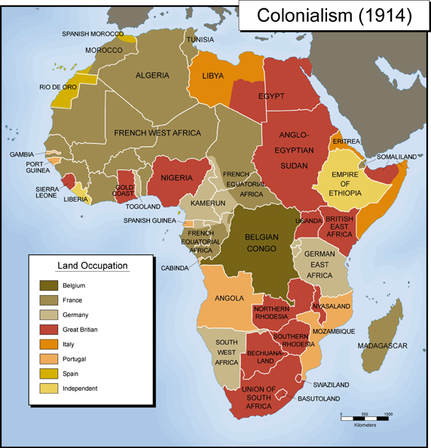
So, why is this important?
First, it’s going to have a huge impact on the countries that have been taken over. The countries that you see to the right had their own culture, customs, and way of life. As the Europeans take over, they lose all of that. The impact of imperialism in for these countries is huge.
But it also has a major impact on the countries that are doing the conquering; it makes them wealthier; gives them more areas to establish military bases; and it allows them to spread their culture throughout the world.

Part three: International Markets – CHINA
Check out this cartoon. The pie represents China. Germans, Russia, British, Japanese, French…they are all cutting into the pie, hoping to get a slice. The Chinese man depicted in the cartoon is yelling, “Stop! You may NOT have a piece of the pie!”
This cartoon was probably created around 1899-1900, during the Age of Imperialism.
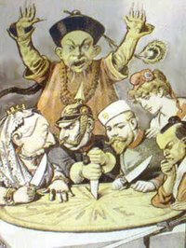
You see, during this time, China was of interest to many countries. They have a vast amount of land and resources. Also, their location near the Pacific Ocean would give countries access to that side of the world.
United States worried that China would be lost through imperialism to European countries, and wanted to ensure that it did not happen.
Why, you ask?
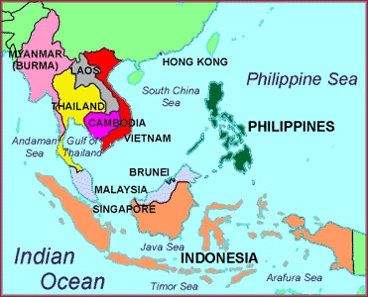
Well, in 1898, the U.S. had annexed (taken over) the Philippines, which are basically right next to China. With the U.S. proximity to China, it created an important trading partner. If the European countries took over China (carved it up, as the cartoon represents, then the U.S. would have lost that trading partner!
Secretary of State John Hay (under William McKinley’s Presidency) knows that something must be done! He creates an “Open Door Policy” for China. This policy proposed that China would not be taken over, and all nations would have equal trading rights in China. This kept Russia, Japan, Britain, France, and all those other countries from trying to expand into this region. It created equal trade with China among foreign countries. China must have felt a sense of relief when it was not colonized!
China
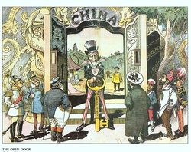

Uncle Sam (USA) protecting China through
Open-Door Policy
Part four: Big Stick Diplomacy vs. Dollar Diplomacy
First, understand this…Diplomacy is how one country handles relations with another country.
Following the 1898 Spanish American War, the United States was a legitimate world power. As such, they were going to have to deal with countries throughout the world on a regular basis. From 1900 on, how the U.S. handled those countries was very important, and continues to be important to this day.
There are two types of diplomacy that I want to compare though. Teddy Roosevelt’s “Big Stick Diplomacy,” and William Howard Taft’s “Dollar Diplomacy.

Teddy Roosevelt’s Big Stick Diplomacy
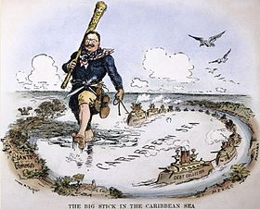
First, understand Teddy Roosevelt. He was never supposed to become president. He was Vice President under William McKinley, but when McKinley died in 1900, Teddy took over. But his life story is amazing. Teddy was sick as a child; his father often stayed home to look after him. Due to this, when it was time for his father to serve in the Civil War, he hired a substitute to fight for him. This is something that Teddy wished his father had not done; he thought it to be ones responsibility to fight for their country, and hoped that he himself would one day have a chance. When the Spanish American War began in 1898 (largely as a result of him), he resigned from his position as Assistant Secretary of the Navy, and created his own fighting regiment (group), called the Rough Riders. They fought famously during the Spanish American War, and within months, he was a hero.
Teddy had a way to get what he wanted, and this was true his whole life. He never took ‘no’ for an answer. His entire life, he found ways to get the things he wanted.
And that takes us to “Big Stick Diplomacy.” As president, his foreign policy (diplomacy) was just that—“Speak softly, but carry a big stick.” Ask for what you want (speak softly), but if it is not given to you, carry a big stick (he created the largest, most powerful navy in the world), and be ready to take it from the country. Most famous example: The country of Columbia controlled the smaller, neighboring country of Panama. Teddy wanted the land of Panama, so that he could build a canal. He asked Columbia for the land. They said no. He offered money. They refused. So he sent his navy down there, forced the Columbians out of the land, and took it himself. From 1904 to 1914, America built a canal there (Panama Canal), and controlled the land for the next 100 years.
Speak softly & carry a big stick; anyone interfering with the Americas will be asked to leave; if they don’t, USA will use military force against them!

Dollar Diplomacy
William Howard Taft, Teddy Roosevelt’s chosen successor, had a different policy, and it did not call for force. This was “Dollar Diplomacy.” In this, Taft urged American banks and businesses to invest in Latin America. By investing in Latin America, those countries would have much stronger economies, and become strong allies and trading partners with the U.S.A. Additionally, if any type of unrest developed in those countries (civil wars, attacks from outside countries, etc...), the U.S. would step in to help out and ensure the protection of U.S. businesses in that region. So Taft—invest in those countries; use money as power. Roosevelt—act as a police force in those countries.

Part five: Spanish American War
The Spanish American took place in 1898, and lasted only six months. However, its impact on world events was significant and lasted much longer.
The Spanish, through imperialism, had control of Cuba (just south of Florida), as well as the Philippines, Guam, and Puerto Rico. Cuban rebels, suppressed by Spanish rule, declared that they wanted to gain independence from the country. Hey, Americans were fighting for independence just 125 years earlier, so they knew what it was like! They could support this cause!
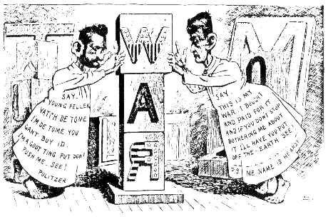
Many people in the U.S. had business interests in Cuba. Cuba was known for its extensive sugar plantations, and many Americans made money off of this crop. If the Spanish had control in Cuba, they’d take over the sugar plantations and Americans would lose millions of dollars.
In addition, U.S. newspapers had a huge impact on the beginning of the war. Two newspapers, competing for business in New York City, needed a story to sell. In an effort to sell more newspapers, they began to exaggerate news reports from Cuba. Stories about the evil Spanish empire began to anger Americans! “Spanish Commanders are feeding Cubans to sharks,” these articles would say! Americans could not believe that the Cubans were being treated so bad. These exaggerated news reports were known as “Yellow Journalism,” after the “Yellow Kid” cartoon that frequently appeared in these New York World.
Yellow Journalism – Exaggerated news reports that helped lead to war.
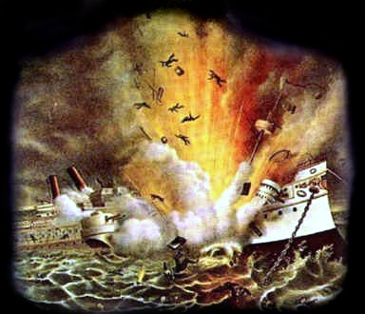
The U.S.S. Maine, a United States battleship, was stationed right outside of Havana Harbor in Cuba, when on February 15, 1898, an explosion occurred, sinking the ship. Nobody was quite sure what happened. However, the newspapers (Yellow Journalism) immediately pointed to Spain as the country to blame! Americans were angered and were ready for war!
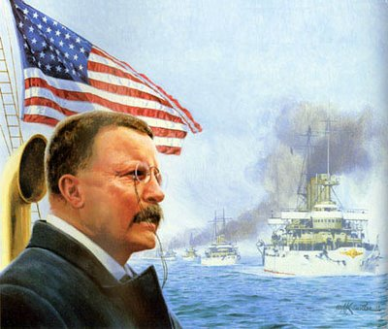
William McKinley was President. Teddy Roosevelt, at the time, was assistant Secretary to the Navy. Teddy was hungry for a war! When Teddy’s boss was not around, he ordered General George Dewey to attack the Spanish controlled base of the Philippines! The Spanish American War had begun, thanks to the actions of Mr. Roosevelt! Once the war began, Teddy resigned from his position as Assistant Secretary to the Navy, and began his own fighting group, called the “Rough Riders.” He led this group of friends, which included politicians, lawyers, cowboys, farmers, and the best poker player in the West, down to Cuba, where they would victoriously fight the Spanish.
The war ended in less than six months. The U.S. won. Results of the war? Cuba gained their independence (from Spain). U.S. annexed (gained) the territories of Guam, Puerto Rico, and the Philippines (from Spain); U.S. became a World Power!

Name: ____________________________- Imperialism Stations
Station one- A time of Change:
1. List three groups of people that faced difficult times from 1870-1920): _____________, ____________, ____________
2. List the three Progressive Presidents: _______________________, ___________________, ______________________
3. As countries began to take over other countries, what did that time period become known as? Age of _____________
4. What famous strike took place at Carnegie’s steel mill in 1892? ______________________________
Station two- Creation of National Markets:
1. What continent was taken over in the 1800s? _______________________________
2. When one country takes over another, what are some benefits? ___________________________________________
3. Taking over other countries in order to expand is known as: ____________________________________
4. Do you think countries should be allowed to take over other areas in order to gain power? Why or why not?
____________________________________________________________________________________________________________________________________________________________________________________________________
Station three- International Markets – China
1. What was going on with China in the late 1800s? ________________________________________________________
2. Why was the U.S. concerned? _______________________________________________________________________
3. What area had the U.S. taken over in 1898? ________________________________
4. What was John Hay’s policy called? ________________________________
5. What did this policy state? __________________________________________________________________________
Station four – Big Stick Diplomacy vs. Dollar Diplomacy
1. What is diplomacy? _______________________________________________________________________________
2. What was Teddy Roosevelt’s diplomacy called? __________________________ Tafts? _________________________
3. Explain “Speak Softly but carry a big stick” _____________________________________________________________
__________________________________________________________________________________________________
4. What was the most famous example of “Big stick diplomacy”? _____________________________________________
5. Explain “Dollar Diplomacy” __________________________________________________________________________

Station five – Spanish American War
1. What country had control of Cuba going into 1898? ________________________________
2. Why did Americans support Cuban rebels fighting for independence? ________________________________
3. What business interests did Americans have in Cuba? _______________________________
4. What is Yellow Journalism? _________________________
5. What was the significance of the USS Maine? ________________________________
6. What role did Teddy play in the war? __________________________________________________________________________________________________________________________________________________________________________________________________
7. Results of the war:
- _________________________________________________________________
b. ________________________________________________________________
c. ________________________________________________________________

