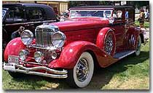
Part one: The Age of the Automobile
Perhaps no invention affected American everyday life in the 20th century more than the automobile.
Although the technology for the automobile existed in the 19th century, it took Henry Ford to make the useful gadget accessible to the American public. Ford used the idea of the assembly line for automobile manufacturing. He paid his workers an unprecedented $5 a day when most laborers were bringing home two, hoping that it would increase their productivity. Furthermore, they might use their higher earnings to purchase a new car.
Ford reduced options, even stating that the public could choose whatever color car they wanted — so long as it was black. The Model T sold for $490 in 1914, about one quarter the cost of the previous decade. By 1920, there were over 8 million registrations. The 1920s saw tremendous growth in automobile ownership, with the number of registered drivers almost tripling to 23 million by the end of the decade.

Effects of the Automobile
The social effects of the automobile were as great. Freedom of choice encouraged many family vacations to places previously impossible. Urban dwellers had the opportunity to rediscover pristine landscapes, just as rural dwellers were able to shop in towns and cities. Teenagers gained more and more independence with driving freedom. Dating couples found a portable place to be alone as the automobile helped to facilitate relaxed sexual attitudes.
Americans experienced traffic jams for the first time, as well as traffic accidents and fatalities. Soon demands were made for licensure and safety regulation on the state level. Despite the drawbacks, Americans loved their cars. As more and more were purchased, drivers saw their worlds grow much larger.
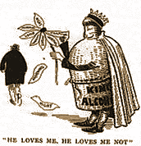
Part two: The Fight Against "Demon Rum"
Saloons were closed, bottles were smashed, and kegs were split wide open. When the states ratified the Eighteenth Amendment in 1919, the manufacture, sale, and transportation of alcoholic beverages was outlawed. Protestant ministers and progressive politicians rejoiced and proclaimed a holier and safer America. It was predicted that worker productivity would increase, families would grow closer, and urban slums would disappear. Yet for all its promise, prohibition was repealed fourteen years later, after being deemed a dismal failure.

Advantages to Prohibition
In fairness, there were advantages to prohibition. Social scientists are certain that actual consumption of alcohol actually decreased during the decade. Estimates indicate that during the first few years of prohibition, alcohol consumption declined to a mere third of its prewar level. Although no polls or surveys would be accurate, health records indicate a decrease in alcoholism and alcohol-related diseases such as cirrhosis of the liver. Family savings did increase during the decade, but it was difficult to determine whether the increase was due to decreased alcohol consumption or a robust economy.

Disadvantages to Prohibition
The minuses seemed to outweigh the pluses. First, there were not enough federal funds to enforce prohibition. Alcohol possession was permitted for medical purposes, and production of small amounts was permitted for home use. A climate of lawlessness swept the nation, as Americans everywhere began to partake in illegal drink. Every city had countless speakeasies, which were not-so-secret bars hidden from public view.
While the number of drinkers may have decreased, the strength of the beverages increased. People drank as much as they could as fast as they could to avoid detection. Because alcoholic production was illegal, there could be no regulation. Desperate individuals and heartless profiteers distilled anything imaginable, often with disastrous results. Some alcohol sold on the black market caused nerve damage, blindness, and even death. While women of the previous generation campaigned to ban alcohol, the young women of the twenties consumed it with a passion.
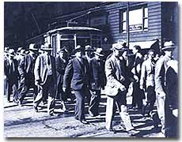
Organized Crime
The group that profited most from the illegal market was organized crime. City crime bosses such as Al Capone of Chicago sold their products to willing buyers and even intimidated unwilling customers to purchase their illicit wares. Crime involving turf wars among mobsters was epidemic. Soon the mobs forced legitimate businessmen to buy protection, tainting those who tried to make an honest living. Even city police took booze and cash from the likes of Al Capone. After several years of trying to connect Capone to bootlegging, federal prosecutors were able to convict him for income tax evasion.
The Eighteenth Amendment was different from all previous changes to the Constitution. It was the first experiment at social engineering. Critics pointed out that it was the only amendment to date that restricted rather than increased individual rights. Civil liberties advocates considered prohibition an abomination. In the end, economics doomed prohibition. The costs of ineffectively policing the nation were simply too high. At the deepest point of the Great Depression, government officials finally ratified the Twenty-First Amendment, repealing the practice once and for all.
Flappers
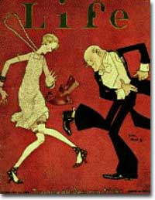
The battle for suffrage was finally over. After a 72-year struggle, women had won the precious right to vote. The generations of suffragists that had fought for so long proudly entered the political world. Susan B. Anthony, Elizabeth Stanton, and many other female activists dedicated their lives to women gaining equality. To their dismay, the daughters of this generation seemed uninterested in these grand causes. As the 1920s roared along, many young women of the age wanted to have fun.

Life of the Flappers
Flappers were northern, urban, single, young, middle-class women. Many held steady jobs in the changing American economy…but the flapper was not all work and no play.
By night, flappers engaged in the active city nightlife. They frequented jazz clubs and vaudeville shows. Speakeasies were a common destination, as the new woman of the twenties adopted the same carefree attitude toward prohibition as her male counterpart. Ironically, more young women consumed alcohol in the decade it was illegal than ever before. Smoking, another activity previously reserved for men, became popular among flappers.

The Flapper Look
The flapper had an unmistakable look. The long locks of Victorian women lay on the floors of beauty parlors as young women cut their hair to shoulder length. Hemlines of dresses rose dramatically to the knee. The cosmetics industry flowered as women used make-up in large numbers. Flappers bound their chests and wore high heels.
Many women celebrated the age of the flapper as a female declaration of independence. Experimentation with new looks, jobs, and lifestyles seemed liberating compared with the socially silenced woman in the Victorian Age. The flappers chose activities to please themselves, not a father or husband.
46e. The Harlem Renaissance
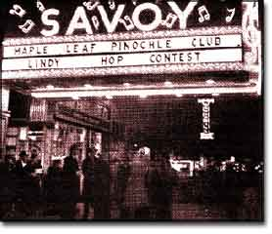
It was time for a cultural celebration. African Americans had endured centuries of slavery and the struggle for abolition. The end of bondage had not brought the promised land many had envisioned. Instead, white supremacy was quickly, legally, and violently restored to the New South, where ninety percent of African Americans lived. Starting in about 1890, African Americans migrated to the North in great numbers. This Great Migration eventually relocated hundreds of thousands of African Americans from the rural South to the urban North. Many discovered they had shared common experiences in their past histories and their uncertain present circumstances. Instead of wallowing in self-pity, the recently dispossessed ignited an explosion of cultural pride. Indeed, African American culture was reborn in the Harlem Renaissance.

The Great Migration
The Great Migration began because of a "push" and a "pull." Disenfranchisement (a lack of voting rights) and Jim Crow laws led many African Americans to hope for a new life up north. Hate groups and hate crimes cast alarm among African American families of the Deep South. The promise of owning land had not materialized. Most blacks toiled as sharecroppers trapped in an endless cycle of debt. These factors served to push African Americans to seek better lives. The booming northern economy forged the pull. Industrial jobs were numerous, and factory owners looked near and far for sources of cheap labor.
Unfortunately, northerners did not welcome African Americans with open arms. Here, they found de facto segregation. White laborers complained that African Americans were flooding the employment market and lowering wages. Most new migrants found themselves segregated by practice in run down urban slums. The largest of these was Harlem. Writers, actors, artists, and musicians glorified African American traditions, and at the same time created new ones. In the Harlem Renaissance, African Americans experienced a time period of great cultural celebration through arts, literature, and music.

Writers and Actors
The most prolific writer of the Harlem Renaissance was Langston Hughes. Hughes cast off the influences of white poets and wrote with the rhythmic meter of blues and jazz. Zora Neale Hurston was noticed quickly with her moving novel, Their Eyes Were Watching God. Music met prose in the form of musical comedy.

Musicians
No aspect of the Harlem Renaissance shaped America and the entire world as much as jazz. Jazz flouted many musical conventions with its syncopated rhythms and improvised instrumental solos. Thousands of city dwellers flocked night after night to see the same performers. Improvisation meant that no two performances would ever be thfe same. Harlem's Cotton Club boasted the talents of Duke Ellington. Singers such as Bessie Smith and Billie Holiday popularized blues and jazz vocals. Jelly Roll Morton and Louis Armstrong drew huge audiences as white Americans as well as African Americans caught jazz fever.

A Consumer Economy
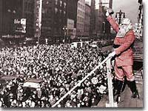
The 1920s was a decade of increasing conveniences for the middle class. New products made household chores easier and led to more leisure time. Products previously too expensive became affordable. New forms of financing allowed every family to spend beyond their current means. Advertising capitalized on people's hopes and fears to sell more and more goods.

Changing Housework
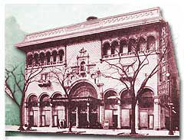
By the end of the 1920s, household work was revolutionized. A typical work week for a housewife before the twenties involved many tedious chores. All the furniture was moved off the carpets, which were rolled up and dragged outside to beat out the week's dirt and dust. The ice in the icebox was replaced and the water pan that lay beneath was repeatedly changed. The clothes were scrubbed in a washing tub on a washboard. An iron was heated on the stove to smooth out the wrinkles. Women typically spent the summer months canning food for the long winter. Clothes were made from patterns, and bread was made from scratch. Very few of these practices were necessary by the end of the decade. Vacuum cleaners displaced the carpet beater. Electric refrigerators, washing machines, and irons saved hours of extra work. New methods of canning and freezing made store-bought food cheap and effective enough to eliminate this chore. Off-the-rack clothing became more and more widespread. Even large bakeries were supplying bread to the new supermarkets. The hours saved in household work were countless.

Buying on Credit
"Buy now, pay later" became the credo of many middle class Americans of the Roaring Twenties. For the single-income family, all these new conveniences were impossible to afford at once. But retailers wanted the consumer to have it all. Department stores opened up generous lines of credit for those who could not pay up front but could demonstrate the ability to pay in the future. Similar installment plans were offered to buyers who could not afford the lump sum, but could afford "twelve easy payments." Over half of the nation's automobiles were sold on credit by the end of the decade. America's consumers could indeed have it all, if they had an iron stomach for debt. Consumer debt more than doubled between 1920 and 1930.

Advertising
Advertising began to change in the 1920s…rather than concentrating simply on what the product was, ads began to concentrate instead on how one would feel when using the product. They used emotion as a way to get the consumer to purchase the product.
The advertising business created demand for the gadgets and appliances being manufactured by American factories.

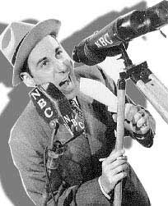
46g. Radio Fever
KDKA on the Air
On the night of November 2, 1920, radio engineer Frank Conrad and his Westinghouse associates announced that Warren G. Harding had defeated James Cox to become the next President. The message was heard as far north as New Hampshire and as far south as Louisiana. The federal government granted the call letters KDKA to the Pittsburgh station and a new industry was born. For nearly a year, KDKA monopolized the airwaves. But competition came fast and furious; by the end of 1922, there were over 500 such stations across the United States.

.

Ad Time
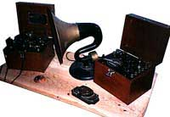
One of the great attractions to the radio listener was that once the cost of the original equipment was covered, radio was free. Stations made money by selling air time to advertisers. The possibility of reaching millions of listeners at once had advertising executives scrambling to take advantage. By the end of the decade advertisers paid over $10,000 for an hour of premium time.
The Radio Corporation of America created a new dimension to the venture in 1926. By licensing telephone lines, RCA created America's first radio network and called it the National Broadcasting Company. For the first time, citizens of California and New York could listen to the same programming simultaneously. Regional differences began to dissolve as the influence of network broadcasting ballooned. Americans listened to the same sporting events and took up the same fads. Baseball games and boxing matches could now reach those far away from the stadiums and arenas. A mass national entertainment culture was flowering. Because people all across the country could listen to the same events, the same music, and the same advertisements, a national culture began to develop.

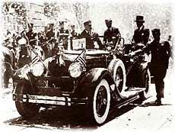
Fads and Heroes
The Roaring Twenties was a time of great change. As exciting as dynamic times may seem, such turmoil generates uncertainty. Sometimes, in an effort to obscure tensions, people seek outlets of escape. Fads — sometimes entertaining, sometimes senseless — swept the nation. Another coping strategy in a time of great uncertainty is to find role models who embody tried and true values. National heroes heretofore unknown to peacetime America began to dominate American consciousness.
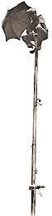

New Fads
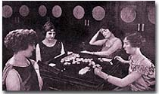
The radio created the conditions for national fads. Without such a method of live and immediate communication, fads could amount only to local crazes. Roaring Twenties fads ranged from the athletic to the ludicrous. One of the most popular trends of the decade was the dance marathon. New dance steps such as the Charleston swept the nation's dance halls, and young Americans were eager to prove their agility. In a typical dance marathon, contestants would dance for forty-five minutes and rest for fifteen. The longest marathons lasted thirty-six hours or more. Beauty pageants came into vogue. The first Miss America Pageant was staged in Atlantic City in 1921. One of the most bizarre fads was flagpole sitting. The object was simple: be the person who could sit atop the local flagpole for the longest period of time. Fifteen-year-old Avon Foreman of Baltimore set the amateur standard — ten days, ten hours, ten minutes, and ten seconds. Crossword puzzle fever swept the nation when Simon and Schuster published America's first crossword puzzle book. The Book-of-the-Month Club drew thousands of readers into literary circles. Two new periodicals began to grace American coffee tables. The nation's first weekly news magazine, Time, was founded by Henry Luce and Briton Hadden.

New Heroes
No individual personified the All-American hero more than Charles Lindbergh. His courage was displayed to the nation when he flew his Spirit of St. Louis from New York to Paris, becoming the first man to fly solo across the Atlantic Ocean. National and international news was hidden in the back pages of the major newspapers while Lindbergh stole the front pages. Confetti flew and bugles sounded in New York City when he returned successfully, and President Coolidge hosted a gala celebration. There was more to Lindbergh's appeal than his bravery. Throughout the ordeal, Lindbergh maintained a hometown modesty. He declined dozens of endorsement opportunities, ever refusing to sell out. Spectator sports provided opportunities for others to grab the limelight. Ty Cobb and Babe Ruth were role models for hundreds of thousands of American boys. Fortunately, Cobb's outward racism and Ruth's penchant for drinking and womanizing were shielded from admiring youngsters. Football had Red Grange, and boxing had Jack Dempsey. Gertrude Ederle impressed Americans by becoming the first woman to swim the English Channel. These heroes gave Americans, anxious about the uncertain future and rapidly fading past, a much needed sense of stability.

